We can’t wait to see your Easter egg designs! Colour, paint or stick on different materials to create your Easter Egg.
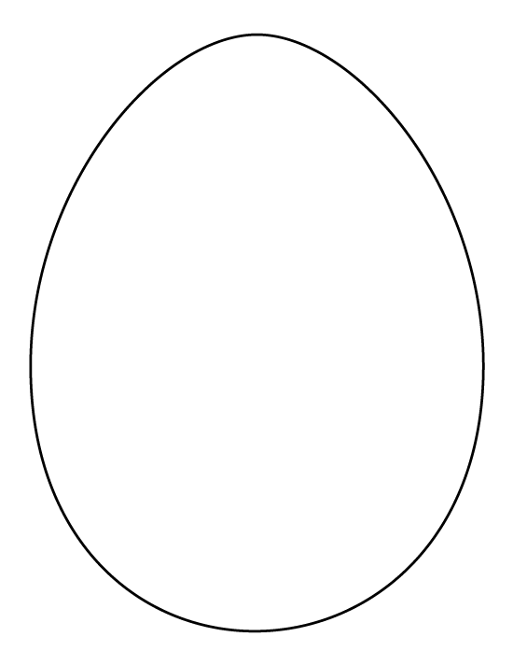
Post or drop off your entries to Charter Court, Newcomen Way, Colchester Business Park, Colchester, Essex, CO4 9YA.

The winner will receive a children’s smart watch! Please submit all entries by Friday 14th April 2023.
Name: ……………………………………………………………………………..
Parents Name: …………………………………………………………………
Phone Number: ……………………………………………………………….
Email Address: …………………………………………………………………
Please tick this box if you do not wish to receive communication from us in the future

